Setting up Veyon for Classroom with ASTER Workplace
Veyon Master Installation
- Download the Veyon 4 Installer from the link and run the installer after download. Click the “Next” button to continue (Figure 1)
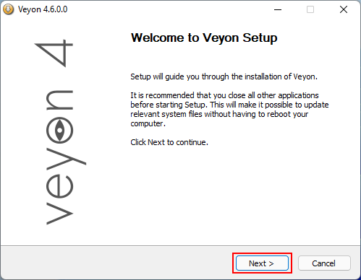
2. Read the “License Agreement” and then click “I Agree” to continue with the installation (Figure 2).
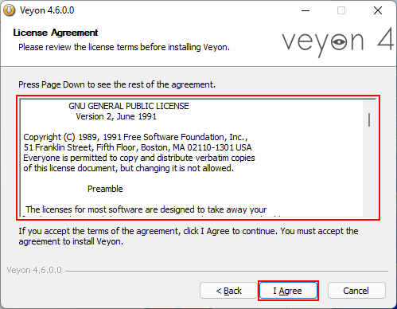
3. Choose the “Destination Folder” for Veyon 4 installation and click the “Next” button (Figure 3).
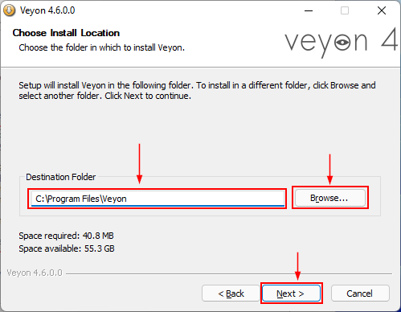
4. Check the “Veyon Master” checkbox along with “Interception driver” and then click the “Install” button (Figure 4).
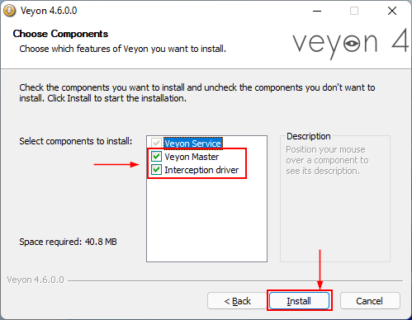
Veyon Master - will install the “Veyon Master” user program to control/manage the clients. Interception driver - is required for intercepting (filtering) user inputs such as key presses.
5. The installation will proceed (Figure 5).
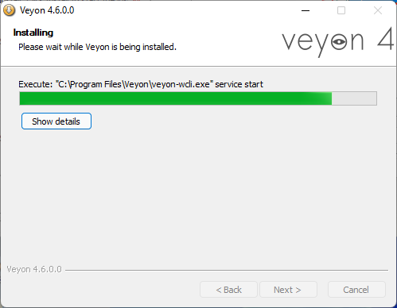
6. Check the “Run Veyon Configurator now” checkbox and click the “Finish” button (Figure 6).
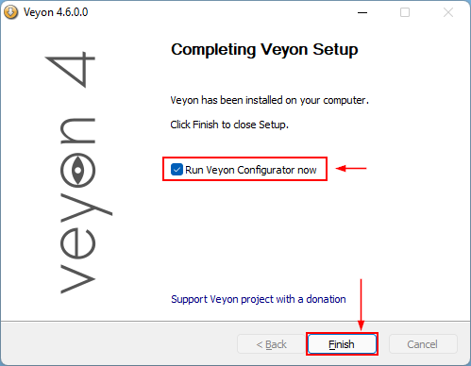
7. On the Veyon Configurator window click the “Authentication keys” and then click on the “Create key pair” button (Figure 7).
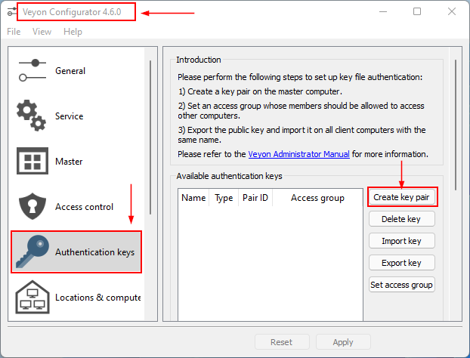
8. It will open the “Authentication key name” dialog box, write the name in the field and click the “OK” button (Figure 8).
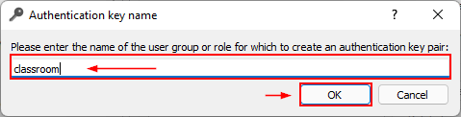
Important: The name entered in the field should be noted down as it will be needed during Veyon client configuration.
9. After clicking the “OK” button, a new key pair will be generated and placed in the path shown in the dialog box, click the “OK” button (Figure 9).
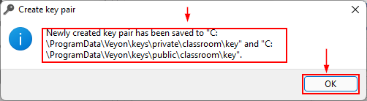
10. The authentication key pairs will be shown in the list, click on the “public” key to select it and click the “Export key” button (Figure 10).
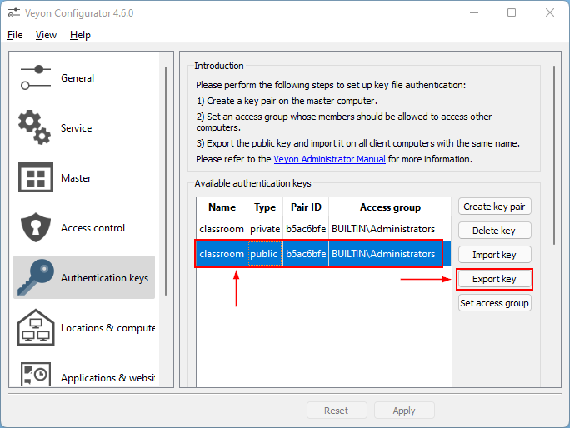
11. Choose the folder/path where you want to export the key and click on the “Save” button (Figure 11).

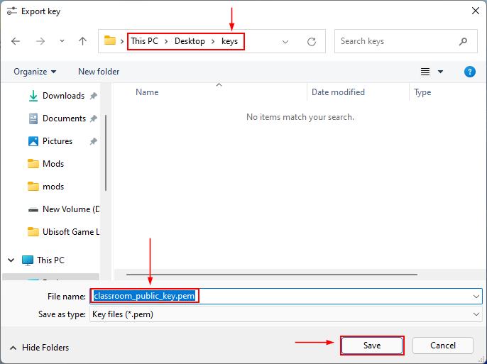
12. The key will be exported to the selected path, click the “OK” button to close the dialog box (Figure 12)
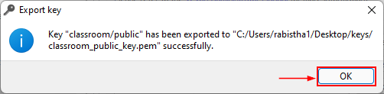
13. Now, click the “Locations and computers” and click the “+” button under “Locations” (Figure 13).
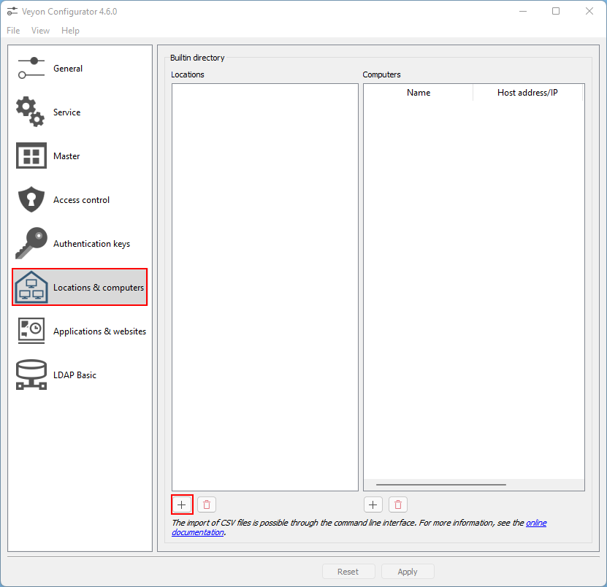
14. It will add “New Location” to the list, double-click it to rename it (e.g. Computer room) (Figure 14).
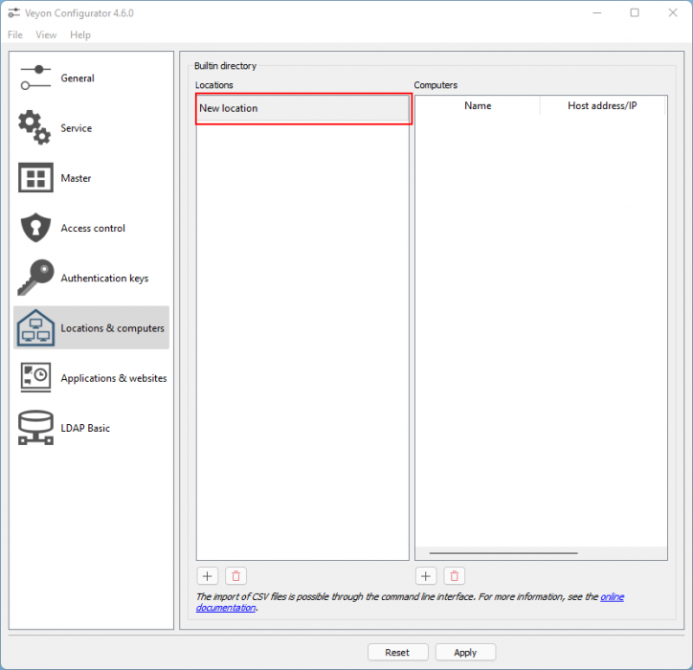
15. Click on the “Computer Room” location to select it and then click the “+” button to add computers to the list (Figure 15).

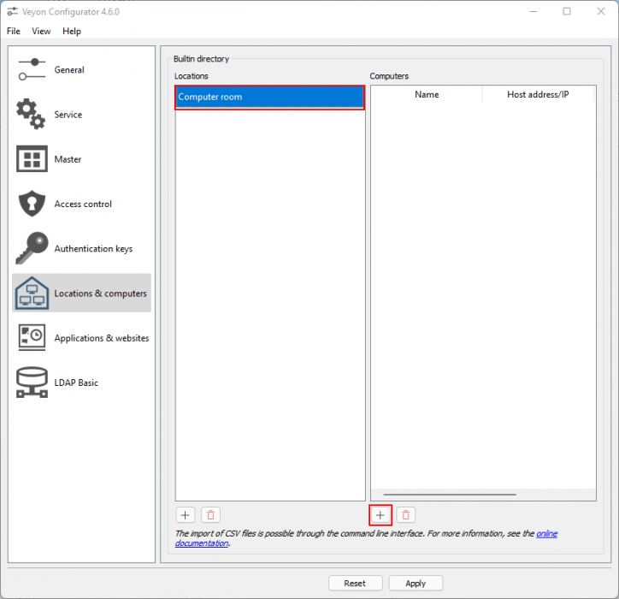
16. Here, 2 computers are added to the list. Double click on the “Name” and “Host address/IP” to edit the fields (Figure 16).
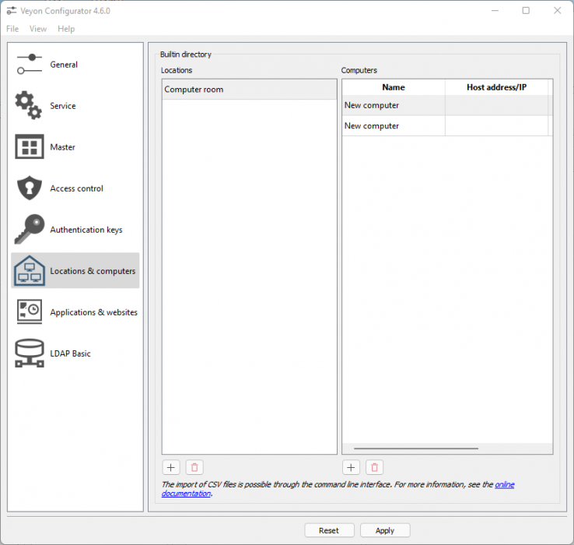17. After editing the computer's “Name” and “Host address/IP), it will look like below (Figure 17).
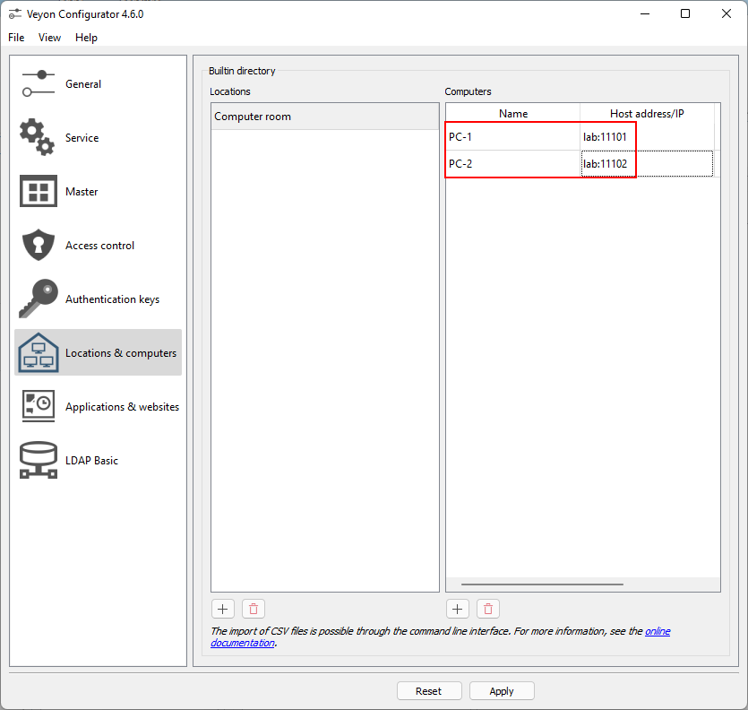
The hostname is used instead of IP address because ASTER PC is set to dynamic IP and hostname for the computer is “lab”.
Important: To connect to Veyon clients(ASTER workplaces), you need to add a port to the “Host address/IP” after “:”. The default port number is 11100. However, for ASTER workplaces. We will set a unique port for each workplace in the network by setting the “VEYON_SESSION_ID” in the “Environments variables” (Figure 18).
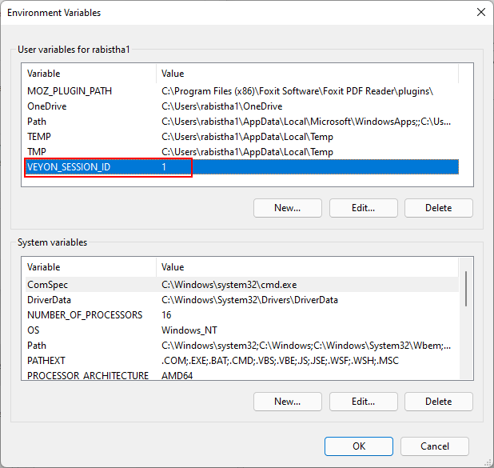
Port number for each ASTER workplace is created by replacing the last digit of the default port number with the “VEYON_SESSION_ID” → in this case, port 11101 for PC-1(Workplace 1) and port 11102 for PC-2 (Workplace 2).
18. Now, click the “Apply” button to apply all the changes made in the “Veyon Configurator” (Figure 19).
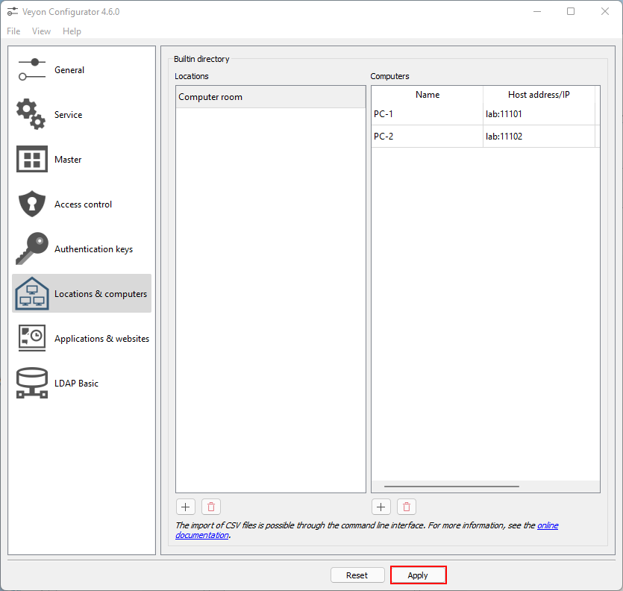
19. Click the “Yes” button to restart the Veyon service (Figure 20).
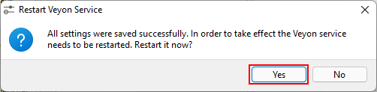
20. Close the “Veyon Configurator” and open “Veyon Master” from the desktop shortcut (Figure 21).
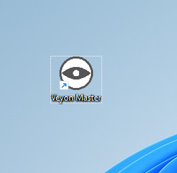
21. On the “Veyon Master” window, click the “Locations & Computers” button to show the “Locations/Computer” list (Figure 22).
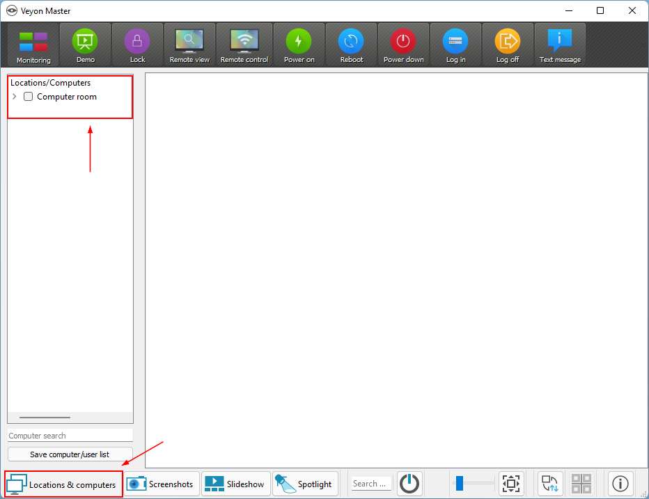
22. Expand the “Computer room” tree and check it to show the PCs in the preview section (Figure 23).
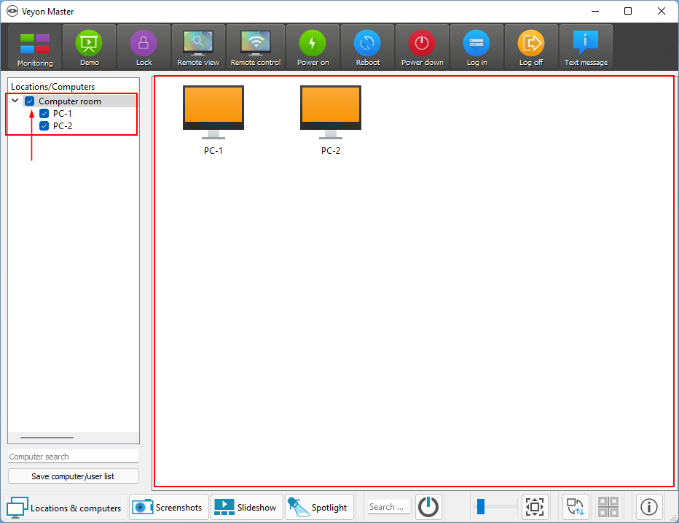
Veyon Client installation
1. Download the Veyon 4 Installer from the link below and run the installer after download. Click the “Next” button to continue (Figure 1)

2. Read the “License Agreement” and then click “I Agree” to continue with the installation (Figure 2).

3. Choose the “Destination Folder” for Veyon 4 installation and click the “Next” button (Figure 3).

4. Uncheck the “Veyon Master” checkbox and then click the “Install” button (Figure 4).
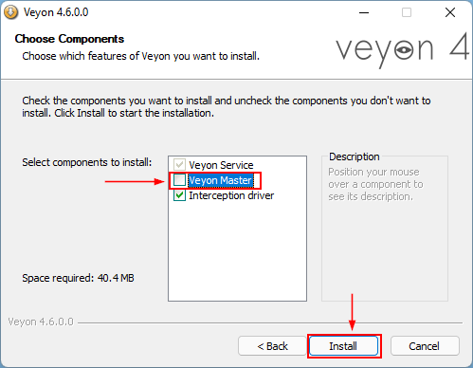
Veyon Master is unchecked as clients do not require it.
5. The installation will proceed (Figure 5).

6. Check the “Run Veyon Configurator now” checkbox and click the “Finish” button (Figure 6).

7. On the Veyon Configurator click on the “Service” and then choose “Multi-session mode” and set the “Maximum session count” to 100 (if not set already) (Figure 7).
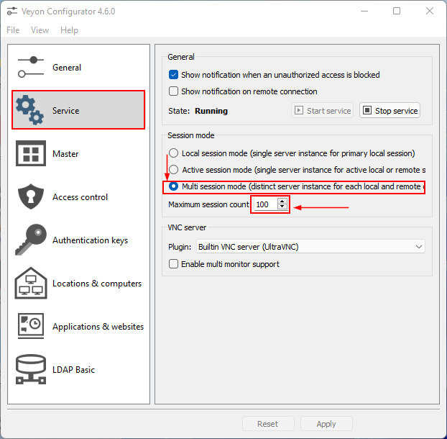
8. Click the “Authentication keys” on the “Veyon Configurator” and then click the “Import key” button (Figure 8).
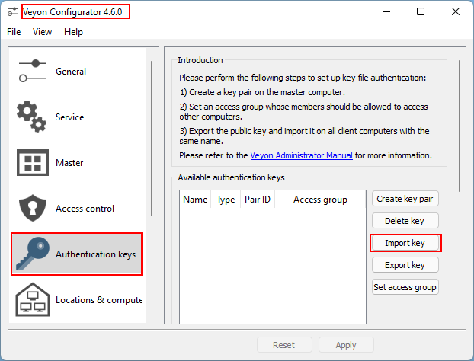9. Copy the public key exported on the server to the pc and select it on the “Import key” window, click the “Open” button (Figure 9).
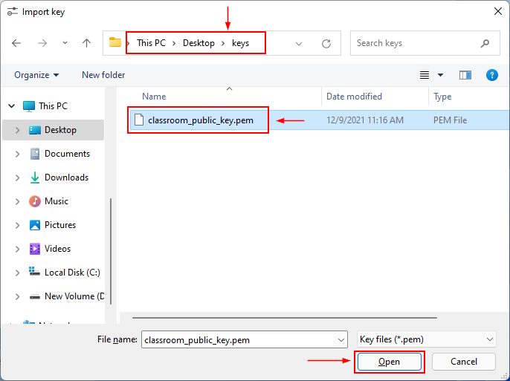
10. Now, you need to enter the same name that you entered on the server when you created the “Authentication key pair” and then click the “OK” button (Figure 10).
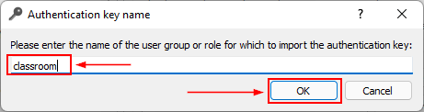
11. The key will be imported, click the “OK” button to close the dialog box (Figure 11).
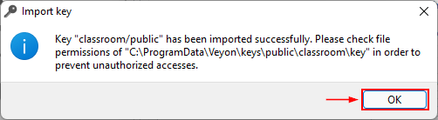
12. Now, We need to set the “Environment Variables” for each workplace with “Variable” as “VEYON_SESSION_ID” and value to match the workplace number.
For workplace 1:

For workplace 2:
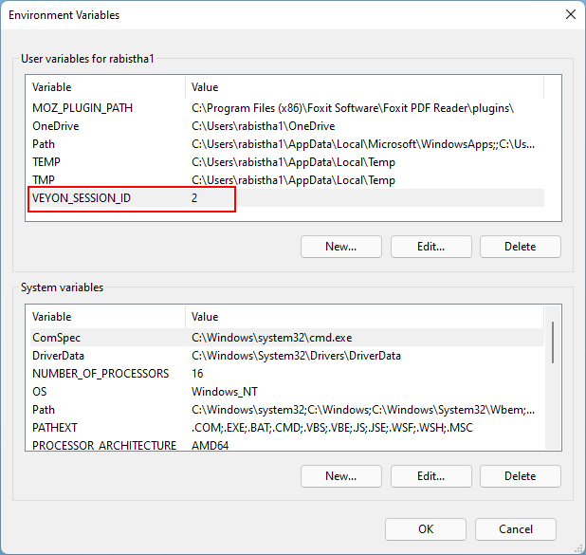
13. Now, we need to start Veyon on the client when the workplaces log on. Open “Task scheduler” and click on “Create Basic Task” (Figure 14).
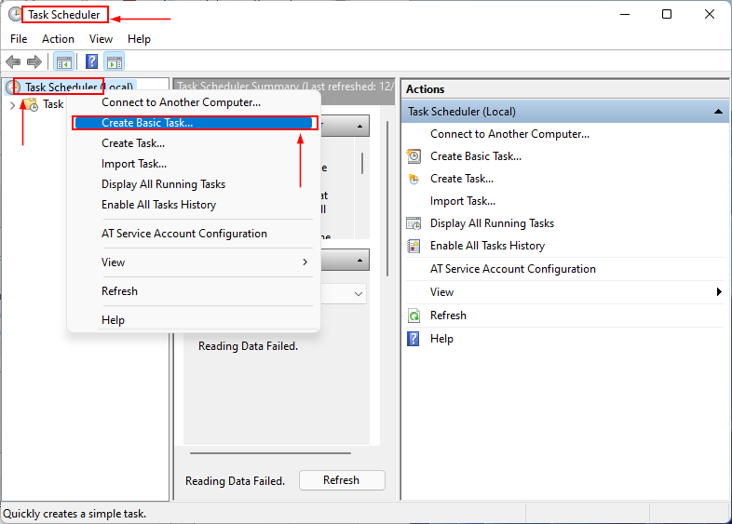
14. Write the name for the basic task and click the “Next” button (Figure 15).
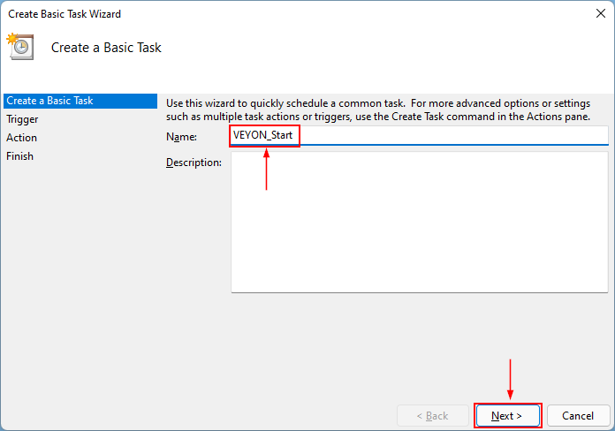
15. Choose “When I log on” in the “When do you want the task to start?” then click the “Next” button (Figure 16).
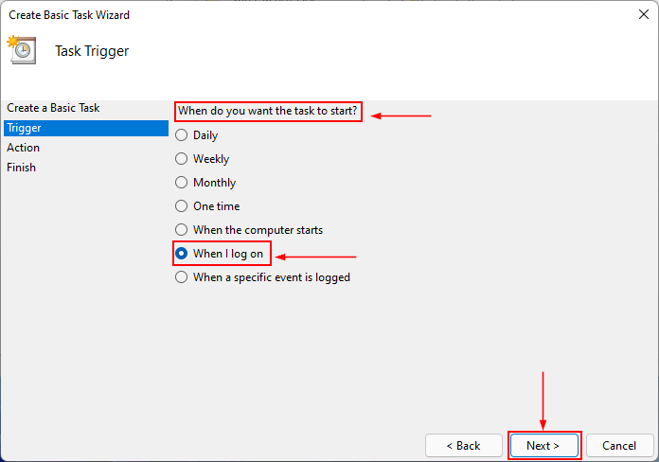
16. On “What action do you want the task to perform?” choose the “Start a program” option and then click the “Next” button (Figure 17).
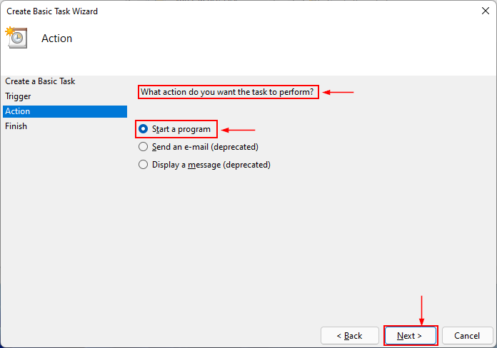
17. Click the “Browse…” button and choose the “veyon-server.exe” file from the “C:\Program Files\Veyon” folder and then click the “Next” button (Figure 18).
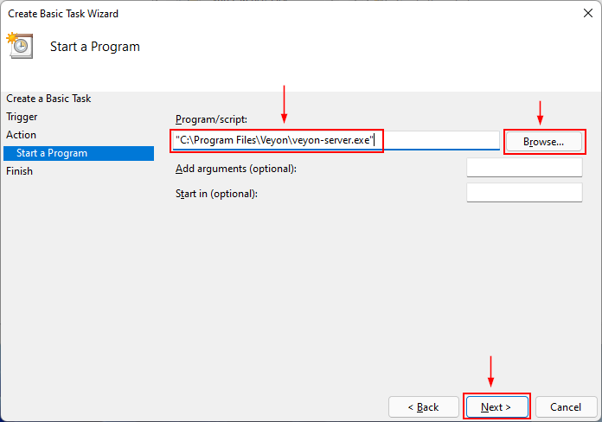
18. Click the “Finish” button to create the schedule (Figure 19).
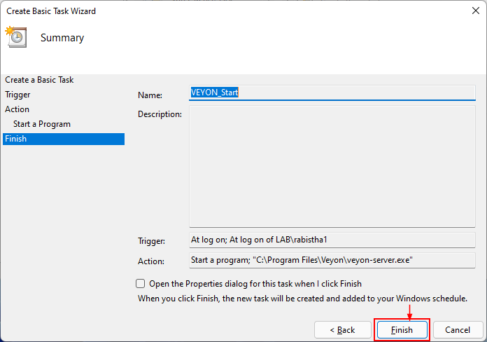
19. Create the same task from your 2nd workplace (user) and your “Task Scheduler” will have 2 tasks for Veyon (Figure 20).
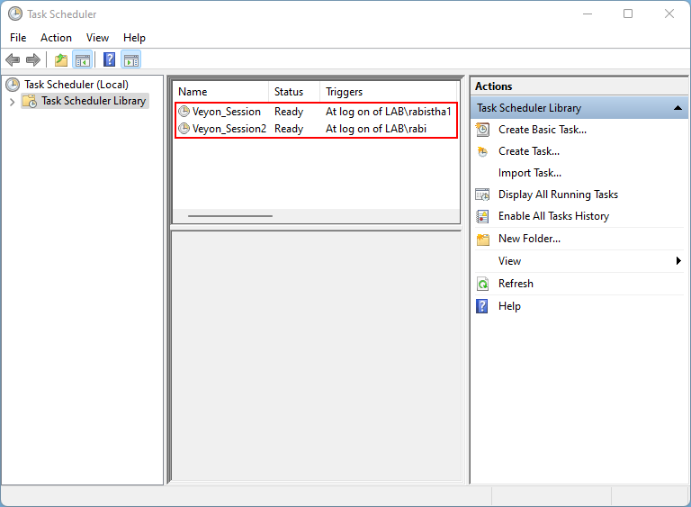
20. Right-click on each task and choose “Run” (Figure 21).
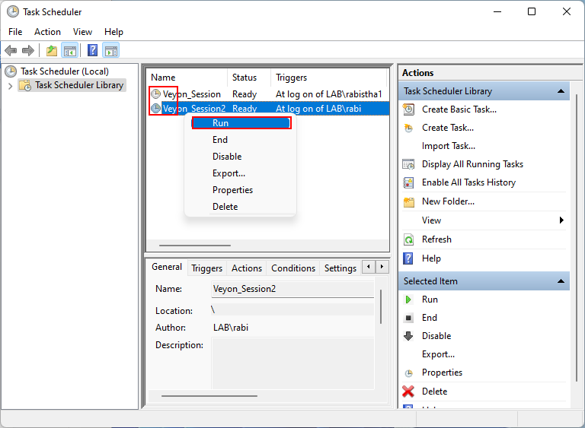
21. Now, Open “Veyon Master” in the master pc and you will see the 2 workplaces “Desktop” preview (Figure 22)
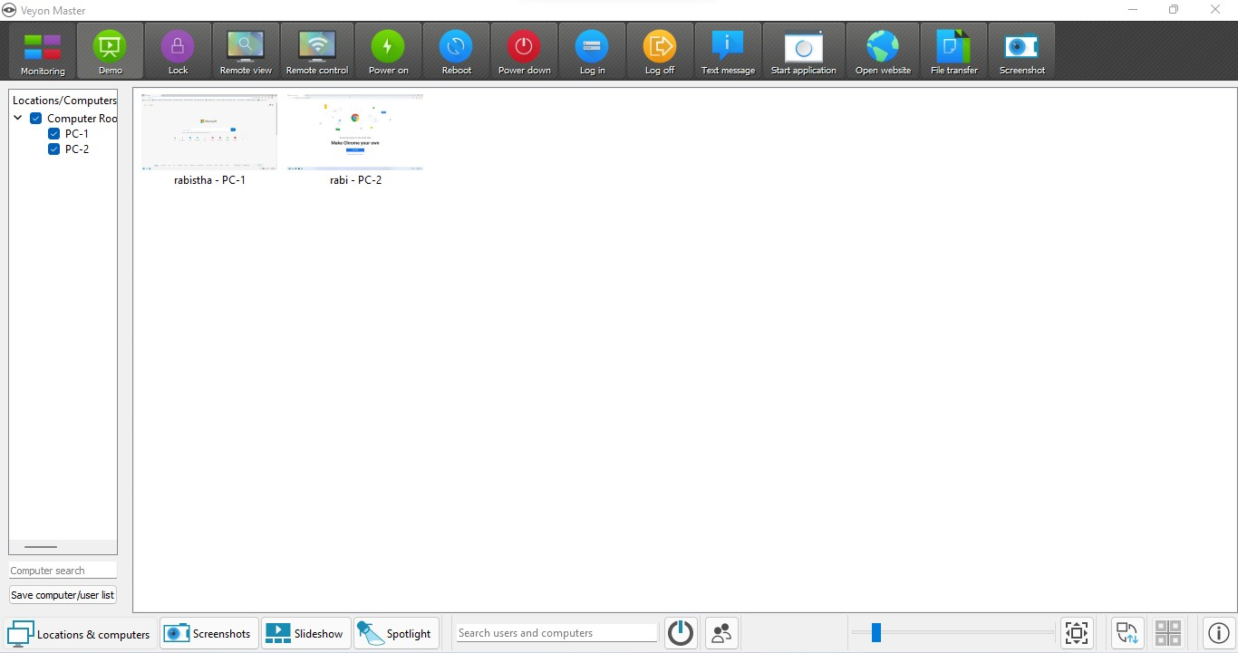
22. Congratulations! Your Veyon is ready to use now.
23. Now, you can lock each workplace, show your screen to each workplace as well as open apps or open websites in browsers of each workplace from “Veyon Master”
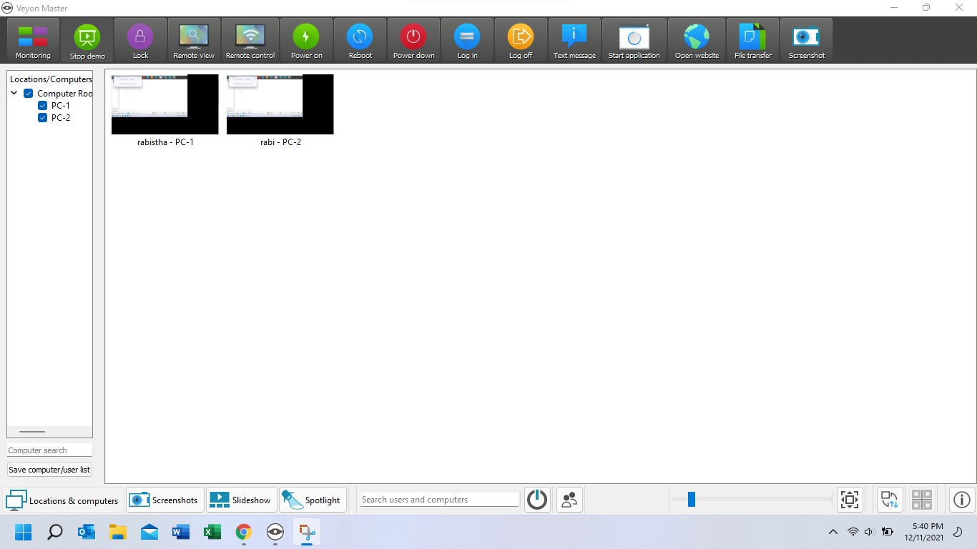
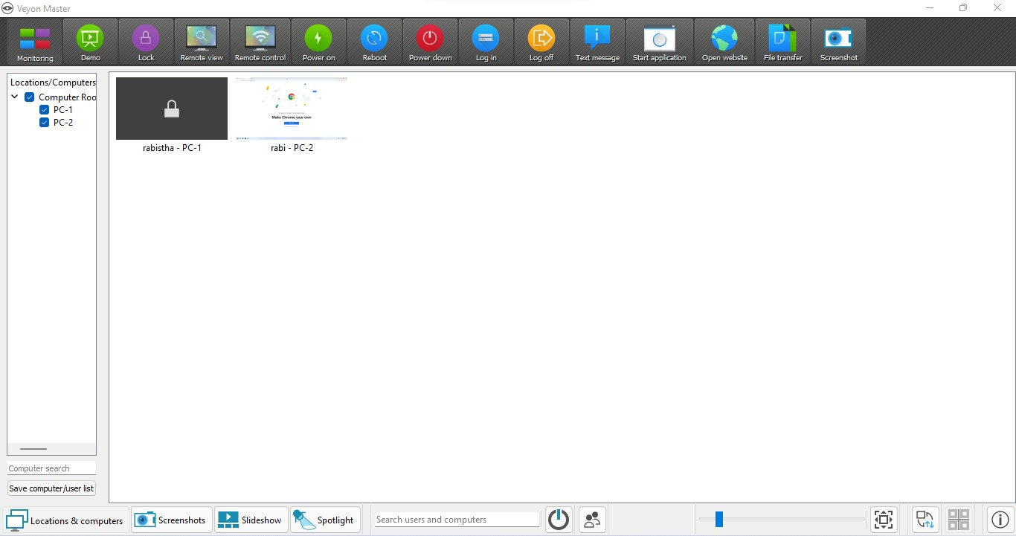
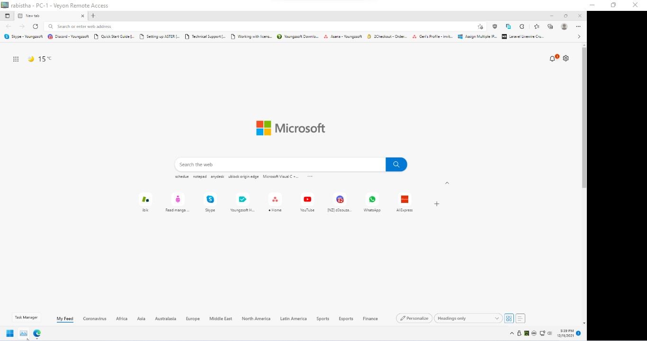
ASTER workplace remote control from Veyon Master
If you have any issue or difficulty in performing any of the steps mentioned in the manual, then do not hesitate to reach out to us.

